**\*\* what is smtp ?**

-- SMTP is used to send and receive email.

SMTP stands for Simple Mail Transfer Protocol. It is a standard protocol on a TCP/IP network for sending emails through servers from one computer to another computer. It is a part of the application layer of the TCP/IP protocol, which makes possible to send email messages over the internet to one or more recipients. So, it is used when an email is sent from an email client, such as Outlook Express or Gmail, to the recipient using email servers.

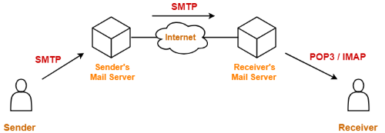

**\*\* what is smtplib ?**

* The smtplib module defines an SMTP client session object that can be used to send mail to any internet machine with an SMTP or ESMTP

listener daemon.

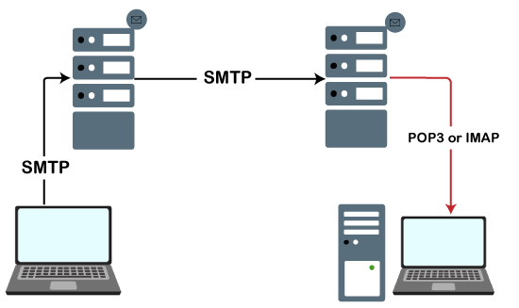

**\*\* what is smt.elho ?**

EHLO command to identify (Specifies the domain name of the sending host ) the domain name of the sending host to SMTP before you issue a MAIL FROM command.

**\*\* what is StartTLS ?**

StartTLS is a protocol command used to inform the email server that the email client wants to upgrade from an insecure connection to a secure one using TLS or SSL. StartTLS is used with SMTP and IMAP.

When an email client uses StartTLS, it informs the server that the content must be encrypted. This way, if the mail is intercepted, the content has been scrambled and is very challenging to decipher. The email server and email client are the only ones that hold the key to decode the message.

